A- 0/2 y.o. Nature | Children playing with building blocks
Description of the activity
The aim - to develop attention, fine motor skills, visual perception, social emotional skills.
- DURATION / TIMING: | Time is not limited for a child or the group of children to finish the task.  Time is monitored for each activity to measure the improvement of learning.
- REQUIRED MATERIALS: | Building blocks coming in different colours.  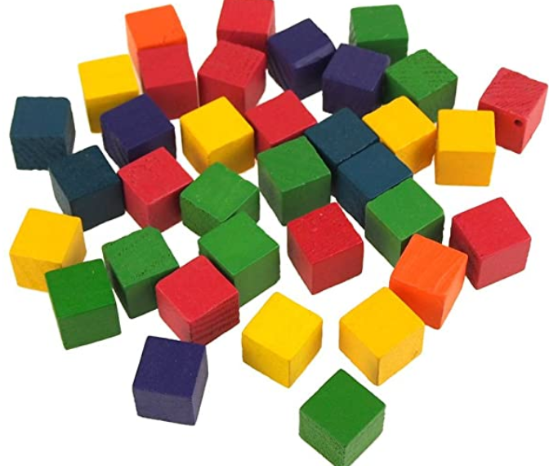
- PREPARATION OF THE ENVIRONMENT: | - A single child with building blocks  A set of wooden blocks  One teacher is ready to build a structure of 5-6 blocks.  One child is repeating the actions of the teacher.  - A group of children with building blocks (1 group of 5 members, location, the material available etc.)  A set of wooden blocks  A group of 2-3 teachers are ready in a team to build a structure of 5-6 (or more) blocks.  A group of 5 children is repeating the actions of the group of teachers.
- DETAILED DESCRIPTION:  How is the activity implemented? | - A single child with building blocks  The task: to copy the structure built by the teacher.  Skills to be developed: attention, fine motor skills, visual perception.  Activities:  The teacher explains to the child what s/he is going to build. The teacher takes wooden blocks of different colours and creates the structure of 5-6 blocks slowly. At first, the teacher shows how to stack two blocks while they develop the fine motor precision and refined grasp to place blocks and releasing their hand without knocking over the blocks. The final structure is a stack of coloured blocks. After building it, the teacher asks the child to copy and develop his/her structure next to the built one. A teacher observes the child and gives some encouragement to finish the task if needed (e.g. by making one more stack of blocks.). After the child completes the activity, the teacher praises his/her efforts and achievement.  For the challenge: 1) Use Blocks to Make Patterns (different levels of difficulty is possible).  The teacher shows how to build a structure of wooden blocks with specific colours and asks the child them to copy his/her block form (e.g. the middle row is only of red blocks (on the left) or all rows are of different the same colour (on the right)).  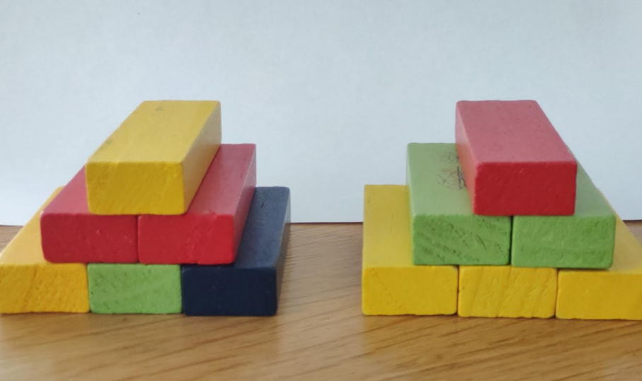  2) Use different sizes, shapes, and even patterns of blocks to make patterns.  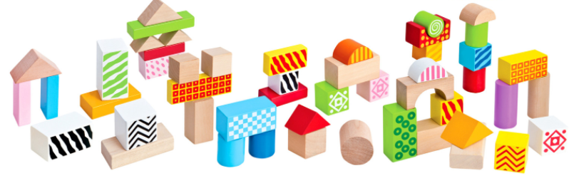  - A group of children with building blocks  The task: to copy the structure built by the group of the teachers.  Skills to be developed: attention, fine motor skills, visual perception, social emotional skills.  Activities:  The group of teachers explains the children of the group what they are going to build as a group. The teachers start to build a structure in turn, step by step explaining what and how they are placing wooden blocks on each other. The group of teachers builds a stack of wooden blocks of different colours consisting of 5-6 blocks. At first, each teacher shows how to stack two blocks while they develop the fine motor precision and refined grasp to place blocks and releasing their hand without knocking over the blocks. The final structure is a stack of coloured blocks. After building it, one teacher of the group asks the group of children to copy and create their form next to the built one. The teachers observe the learning process of the group as a whole and separately each child within the group. If needed, the teachers give some encouragement to children to finish the task (e.g. by building one more stack of blocks.). When the task is completed, the group of the teachers start to build another stack of wooden blocks and ask the children of the group to repeat it. After the group of children finishes the activity, the teachers praise their efforts and achievements.  For the challenge:  1) Use Blocks to Make Patterns (different levels of difficulty is possible).  2) Use different sizes, shapes, and even patterns of blocks to make patterns.
- ROLES of the CHILDREN | - A single child with building blocks  Learner how to copy, observer, experimenter.  Watching and copying friends or waiting for adult encouragement.  When acting, they express their emotions with sounds, words, gestures, facial expressions.  - A group of children with building blocks  Learners to copy, Motivators, Contributors  Watching and copying friends or waiting for adult encouragement. When acting, they express their emotions with sounds, words, gestures, facial expressions.
- ROLE of the TEACHER: | - A single child with wooden blocks  Teacher-initiator, observer, helper.  Teacher-initiator: Sets the example of the stack of wooden blocks, offers the child to copy a stack. Comments on the child's actions, encourages him to express himself. Talk to the child about the impressions, experiences at the end of the activity.  The teacher is an observer: the child acts independently, discovering his ways of acting.  Teacher - helper encourages and provides help if necessary and sets an extra example.  - A group of children with wooden blocks  Teachers’ actions are the same as working with one child.
- Extra resources | -
- Other remarks | Research (Ellis-Rech et al., 2020) tells us that early experiences with blocks stimulate the development of spatial, language, cognitive, and problem-solving skills. All of these are the literal building blocks for higher-level tasks like reading, writing, executive functioning, math, and communication skills. By building with blocks, kids are establishing concepts of cause and effect (that tower falls if I build it too high), reasoning (I need to place the blocks flat on each other, so they don't topple over), and creativity, self-esteem, STEAM concepts, early math, language, and motor planning.  Criteria might be involved in the assessment tool:  - Time spent on each activity by a single child and the group of children.  - A set of emotions: Mimicry, gestures, voice, other actions to express the feelings experienced.  - The number of words or other linguistic expressions announced  - The conformity of the stack built by children to the one built by the teachers (Learning to learn: try to repeat successfully)  - ?
- References, if any | Ellis-Rech, D. R., Lee, E., Wood, N., & Gregg, S. (2020). Interactive STEAM Education for Children: Ball Wall IQP. Interactive Qualifying Projects (All Years). https://digitalcommons.wpi.edu/iqp-all/5706

